Institutional Entrepreneurship and Cultural Consumption: The Making of a “Participant Generation”*

Jennifer C. Lena
Columbia University, Teachers College

Omar Lizardo
University of California, Los Angeles

Keywords: generation, culture, valorization, vernacular, folk, institutions, New Deal, Progressive Era, museums, organizations

Word Count: 9,389

*Earlier versions of this paper were presented at the 2014 Annual Meetings of the American Sociological Association in San Francisco, and at the 2015 Annual Meetings of the American Sociological Association in Chicago. We would like to thank Peter Bearman, Shamus Khan, Adam Reich, Wendy Griswold, and four anonymous reviewers for helpful comments and suggestions. Direct correspondence to Jennifer Lena, 525 West 120th St. Box 78, NYC, NY 10027, Email: jcl42@columbia.edu or Omar Lizardo, olizardo@soc.ucla.edu.

Abstract
We argue that the link between cultural production and consumption domains can be researched by looking at how major institutional transformations in culture delivery and classification systems leave “legacies” encoded in unique generational experiences. Using historical process-tracing, we uncover the mechanisms resulting in the most important period of institutional expansion in availability of the arts for ordinary Americans in the 20th century. We then use data from two surveys to show that this period of expansion and investment left behind an empirically specifiable generational effect on the exposure and breadth of involvement in arts activities for Americans who came of age during this period. Our analysis provides an empirical demonstration of the historically mediated effect of organizational practices and institutional legacies in producing heterogeneity in patterns of cultural choice subsisting to this day.

1.0 Introduction
Historical changes in the institutional organization of artistic production, dissemination, and classification have been linked to the “making” of distinct culture consuming publics (Bourdieu 1993; DiMaggio 1982; Levine 1988). Yet, rather than dealing directly with this linkage, recent work in cultural sociology has been characterized by an increasing segregation of research on production and consumption dynamics. On the production side, we have sophisticated studies of the emergence, consolidation, and transformation of production systems and associated cultural classification regimes for cultural goods (Baumann 2001; Allen and Lincoln 2004; Ferguson 1998; Johnston and Baumann 2007; Lena 2012; Rossman 2012). On the consumption side, attention has centered on putative transformations of elite consumption patterns (Peterson 2005). If the major drawback of production-oriented studies is that they leave implicit the consequences of production-side dynamics for patterns of cultural choice, a key weakness of consumption-oriented studies is that they neglect the generative mechanisms for the genesis and maintenance of cultural tastes (Lizardo and Skiles 2012). As a result, there has been a relative lack of attention to the macro/micro linkage between institutional context and patterns of cultural choice. This paper concerns itself with this issue.
Work on the production of culture, save for some signal exceptions (e.g. Mears 2011; Lena 2012; Ocejo 2014), has lacked systematic examination of how the making of taste publics is contingent on institutional and organizational practices, themselves the product of specific historical trajectories and configurations. In particular, there has been a relative dearth of work empirically examining how differences in patterns of artistic engagement may reflect the “historicality” encoded in individuals because of their distinct generational experiences (Abbott 2016). The result is that we lack a full understanding of the institutional origins of group heterogeneity in the propensity to engage the culture arts (Fishman and Lizardo 2013). In what follows we develop one theoretically generative empirical example of such a legacy effect on cultural choice patterns.
We argue that the link between the production and consumption domains can be researched by looking at how major institutional transformations in culture delivery and classification systems leave generational “legacies” encoded in unique cohort experiences (Abbott 2016; Greve and Rao 2014; Fishman and Lizardo 2013). We thus synthesize work on institutional transformations of cultural classification systems with work on generational effects in culture-consuming publics. Our argument is that historically durable dispositions towards broad forms of participation in art forms previously considered “middle-” or “low-brow” emerged for Americans who experienced significant expansions in the availability, accessibility, and institutional valorization of categories of cultural goods (DiMaggio 2000). From this perspective, the differential distribution of culture consumption propensities in the present results from “institutional legacy” effects linking contemporaneous differentiation in cultural engagement to historical factors operative at a previous point in time (Fishman and Lizardo 2013).
Empirically, we begin by using historical process-tracing to shed light on the mechanisms leading to the most important period of institutional upheaval and expansion in availability of the arts for ordinary Americans in the 20th century. We show how forms of institutional entrepreneurship within and around arts organizations during the New Deal, spurred by then unprecedented levels of public investment in American art, ultimately impacted arts-consuming publics especially those located outside of traditional elite locations. We then use data from two surveys to show that this period of expansion and investment left behind an empirically specifiable generational effect on both early exposure to and breadth of involvement in arts activities for Americans who came of age during this period. Our analysis thus provides an empirical demonstration of the historically mediated effect of organizational practices and institutional legacies producing heterogeneity in patterns of cultural choice subsisting to this day.

2.0 Institutional and Organizational Impacts on Tastes

2.1 The Emergence of High Culture as an Exemplar Case
In an influential article, DiMaggio (1982) attributes the emergence of a distinction between high and popular culture in the U.S. to organizational and institutional transformations that took place in 19th century Boston. This is the period when the grand project of defining an institutional field of “fine arts” culture was pursued by bourgeois, urban elites. This is also the period in which what Levine (1988: 85-168) has referred to as the “sacralization” of the arts began in full force (for recent historical evidence of this phenomenon on the consumption side see Accominotti, Khan and Storer 2018). These fields come to have an organizational base in universities, museums, galleries and other elite-supported non-profit institutions designed for the production, dissemination, and canonization of cultural products; they play a critical role training both artists and consumers in the newly defined principles of cultural valuation (Conner 2008: 113; DiMaggio 2000).
This research reveals an association between organizational factors (the creation and elaboration of the non-profit arts organization) and institutional work (sacralization and purification) accomplished by cultural entrepreneurs (the Boston Brahmins; institutions such as the New York philharmonic; college educated arts bureaucrats) resulting in the production and perpetuation of a new form of taste (“high culture”). It is this sort of bridging work that is still needed as sociologists explore new forms of cultural expression, and new production arrangements. These include the characteristic features of the 20th century’s artistic field: the emergence of diverse culture consuming publics and aesthetic legitimation processes leading to the expansion of the artistic canon (Lizardo 2008). Although scholars have proffered some scattered ideas on the link between these two developments, no single analysis has tried to link the behavioral manifestation with its institutional antecedents. We aim to extend this line of research in what follows.

2.2 Artistic Legitimation and the WPA
By the turn of the 20th century, the non-profit organizational form provided elite art patrons dominion over definitions of “art,” and they turned their attention toward maintaining the new category’s legitimacy by responding to shifting expectations of the role of art at the national level. Later, changing political, social, and economic conditions during the interwar period placed pressure on organizations to change their institutional practices. In particular, arts administrators, dealers, experts, critics, patrons, donors, collectors, artists, and audience members sought to change definitions of “American art” to reflect perceived transformations in the national character: “one of the consequences is that...museums welcome into their halls works that were not considered Art until they were granted entry: African ‘primitive’ works, folk art, comic strips, and even industrial artifacts” (Zolberg 1984: 390). The artistic legitimation of vernacular culture--and what Bourdieu (1965) called les arts moyennes--was the locus of intense cultural entrepreneurship in the first half of the twentieth century.
No movement better illustrates the intensity of 20th century vernacular culture legitimation than the federated state and national arts programs during the 1930s and 40s. Under the auspices of the New Deal programs, federal, state, and local government bodies provided subsidies to individual artists and supported new schools of art, visual art and performing arts events: As Judith Barter notes, “[t]he arts were important. They were visible and they were everywhere in the ‘30s...I think the ‘30s were important because it was a redefinition of American culture. It redefined the way the individual related to government (and) how government related to communities” (quoted in Wooten 2016).
As a direct commissioning agent, government agencies encouraged the production of works that displayed “the American experience” and its “roots in the folk tradition of the people” (Matthews 1975: 334). Administrators of WPA offices encouraged their artists to develop
a local vernacular associated with regional and cultural identity…[a] vernacular of authenticity that could plumb native sources of modern art within an academic tradition, the vernacular of folk art, the vernacular of indigenous traditions and ethnography, the vernacular of the everyday, and the vernacular of regional artists, photographers, and filmmakers giving expression to national consciousness during the lean years of the Great Depression (Umbach and Hüppauf 2005: 25).

Broad-based transformations in the expectations of the art-consuming public resulted from these measures, and arts administrators, curators, and artistic directors worked expeditiously to make that culture available. In so doing, they legitimated vernacular culture, heralding the rise of what some have called a renaissance of “vernacular modernism” (Bacon 2005).
Artists employed under these works programs at the federal, state, and local levels produced an enormous variety of art, including paintings, graphics, motion pictures, murals, photographs, posters, sculptures, and plates for the Index of American Design. Still others taught art and art appreciation; mounted exhibitions, tours, and lectures; built frames and dioramas; and sketched maps. Some creative workers even developed color standards and tested paint in cooperation with the Bureau of Standards. Arguably, the most popular program placed commissioned murals into 1,100 post offices (Park and Markowitz 1984).
State-level support for indigent artists began as early as 1931, but the first Federal, non-relief project for artists, the Public Works of Art project, was started in 1933. A more comprehensive work relief program was announced in August, 1935 and was known as the Works Progress Administration (WPA). Under the WPA, the four programs referred to as “Federal Project Number One” provided subsidies for the production of visual art, music, theater, and literature (and later, the historical records survey). The resulting output of creative material from Federal One is nothing short of astonishing: from 1935 to its closure in June 1943, artists created 2,566 murals, 17,744 sculptures, 108,099 paintings, 250,000 prints from 11,285 images, 2 million posters from 35,000 designs, and over 22,000 design plates (O’Connor 1969: 28-9; Greengard et al. 1986: 58-60). As one historian opined: “the resulting output of Americana was overwhelming” (Mathews 1975: 334).
The expansion of access to artistic production and presentation provided by state and federal subsidy produced two outcomes critical to our argument: first, it diversified both artistic content and personnel; second, new genres were presented as art within benchmark art organizations as objects for aesthetic appreciation, endorsed by legitimate art experts like curators, collectors, and critics.
While not all the arts administrators in charge of disposing of federal and state arts funds embraced the vision of a cultural democracy taken up by Roosevelt, some endorsed it and welcomed new content and creators into art genres. Harry Hopkins, appointed in 1933 to direct monies for actors and musicians, was a member of the latter group; he pushed theater directors to depict the deplorable conditions in tenements hoping it might encourage a landslide of support for the construction of decent housing for American citizens. Administrators in the Theater Division commissioned adaptations of non-theatrical material like pageants, dance dramas, and living newspapers to dramatize the full range of American life. Playwright Percy MacKaye called for a “Drama for Democracy” and theaters that would be a “civic agency” for “the whole people” (N.A. 1936, “Art: Government Inspiration”). Musicologist Charles Seeger was encouraged by the Resettlement Administration to foster the unity of communities by encouraging the use of indigenous musical resources. Seeger had built his career on identifying regional, popular, and folk music and integrating those with academic music into a uniquely American idiomatic expression (Mathews 1975).
Arts administrators labored to legitimate particular forms of vernacular culture as art. Artist Yasuo Kuniyoshi has argued that great American culture was created by WPA “artists [who] were encouraged to...search for roots in the folk tradition of the people, documenting the values and behavior of a culture in the throes of self-recognition” (Matthews 1975: 334). WPA music division director Nikolai Sokoloff presented folk music of a dizzying variety: white and black spirituals, Spanish songs from the Southwest, Creole ballads from Louisiana, liturgical music from California missions, and bayou songs from the Mississippi delta (Mathews 1975: 336). In 1936, Time Magazine reported that Sokoloff’s payroll included a 22-piece “gypsy orchestra” in Pittsburgh, a Hungarian ensemble in Chicago, and típica orchestras in San Antonio and Tucson (N.A. 1936, “Music: Relief Melodies,” 1936). State and federal agencies provided the funding to refurbish and rejuvenate Harlem’s Lafayette Theater, which offered staged Macbeth for over 130,000 audience members (Mathews 1975: 325). Other organizations in ethnic and minority neighborhoods launched or advanced the careers of local artists; the Harlem Art Center presented such shows, including work by now famous painters like Jacob Lawrence.
Operating under the aegis of federal, state, and local governments, some of these works were presented in benchmark arts organizations including the Smithsonian, the National Gallery, the Museum of Modern Art, and the Federal Art Gallery in New York (Greengard et al. 1986). The Public Works of Art Project closed with a gigantic exhibition in Washington at which high-ranking government employees were encouraged to take what they liked and to display the art in their offices. President and Mrs. Roosevelt hosted a series of nine concerts of “traditional” musicians at the White House, including one in June 1939 attended by the King and Queen of England, the first reigning British monarchs to visit the U.S. The playbill included the mountain string band the Coon Creek Girls; Marion Anderson, the contralto opera singer; the North Carolina Spiritual Singers; and musicologist Alan Lomax, who performed cowboy songs. Federal One contributed to a transformation in the organization of art in America: curators and preservationists developed new competencies, organizations presented new kinds of work, new markets opened, and audiences acquired new modes of appreciation.
How lasting were these changes? The record keeping for WPA federal and state agencies was uneven and distributed across more than a hundred offices. We know some art had long careers. The original 22,000 plates from the Index of American Design are still housed at the National Gallery of Art in Washington, DC. The Newark Museum also has a large number of WPA works, including Minna Citron’s painting “Staten Island Ferry.” Yet, many other works produced in the New Deal era were destroyed, abandoned, or forgotten.
It is easier to trace the fate of the WPA arts administrators, some of whom helmed large and influential organizations and brought with them a desire to diversify the art on offer. To trace just a single, important lineage: Holger Cahill left his position as the Director of the Federal Art Project (FAP, 1935-1943), and became a curator at the Newark Museum and then MoMA, where he served as interim director for a year (1932-1933). In both jobs, he worked to canonize material that drew upon the nation’s folk traditions, a modernist project for which MoMA would become famous. Barr was succeeded at MoMA by René d'Harnoncourt, former Manager of the WPA’s Indian Arts and Crafts Board. An advocate of folk art, d'Harnoncourt was an expert in Mexican, vernacular, and modern American art. During his tenure at MoMA (1949-1968), d’Harnoncourt supervised and curated numerous exhibitions of folk material from the U.S. and elsewhere including displays of American woodcuts (1952), “young American printmakers” (1954), paintings by “amateurs” (1955), graffiti (1956), and film posters (1960).
Cahill became a close advisor to Nelson A. Rockefeller, and supported his acquisition of an enormous collection of so-called “primitive art” from Africa, Oceania, and the Americas. Nelson presented this collection as the Museum of Primitive Art in 1957; it housed the nation's most extensive collection of art objects from Africa, Oceania, and the Americas. In the mid-1970s, it was transferred to the Metropolitan Museum of Art (NYC), signaling a shift in the museum’s opinion of these works from anthropological to aesthetic in character, and again, expanding the corpus of what counted as American art (LaGamma et al. 2014). Equally significant changes were taking place in the performing arts as cultural capitalists moved benchmark arts organizations toward the goal of presenting American vernacular culture as art.
The significance of the aesthetic legitimation of some vernacular culture as art can also be seen in the founding of new organizations, and new regulatory and institutional practices. These include the American Folklife Preservation Act of 1976, the American Folklife Center, the Folk Arts Program at the National Endowment of the Arts, and UNESCO’s 2003 International Convention on the Safeguarding of Intangible Cultural Heritage (Kurin 1989: 18-19). These provide additional evidence of the artistic legitimation process taking place.
We hypothesize that the totality of these changes impacted the tastes of Americans coming of age in this era, with the potential to produce a distinct “generation” with a heightened orientation towards arts participation. As argued by Mannheim (1952) in his classic essay, generations are age cohorts that experience the same major events in their lives and subsequently develop similar dispositions and world views. Mannheim argued that people are most susceptible to influence by an event or person if they “came of age” (usually interpreted to be a period between the ages of fifteen and twenty five) at around the same time. Thus, we note historical evidence of significant organizational and institutional changes happening in the coming-of-age years of this potential “participant generation.” As the oldest members of this generation aged into their early adulthood, these transformations matured. College-educated elites among them witnessed the closure of WPA art schools and the slow decline of public murals, but also must have come to expect the presentation of African sculpture and film posters as art—the exception became the norm. This generation should be distinct compared to both the pre-progressive era predecessors and their post-baby boom successors in their higher likelihood to have been exposed to the arts during their coming of age, and in their higher likelihood to sustain greater levels of participation in the arts to this day. We examine evidence pertinent to these two research questions in what follows.

3.0 Did Members Of The Participant Generation Have Early Exposure to the Arts?
The first hypothesis emerging from the historical analysis is that members of the Participant Generation were more likely to be exposed to the arts because of state support, institutionalization, elite advocacy, and aesthetic valorization work starting during the Progressive Era. The historical process-tracing analysis provides strong support for the claim that persons who came age during this period of expansion of the artistic canon and incorporation and sponsorship of American vernacular modernism had the potential to have greater exposure to the arts. Is there direct evidence for this exposure?

3.1 Americans and the Arts Survey
The 1973 Americans and the Arts survey (fielded by the National Research Center of the Arts [1973]) contained a series of items in which interviewees were asked about their level of exposure to the arts when they were growing up. Respondents were selected via a multistage, cluster random sampling design; thus, when weighted, the data are representative of the U.S. population at the time. This survey is appropriate for our purposes as it is one of the oldest data sources, thus ensuring good representation of progressive era cohorts, containing information on childhood exposure to the arts.
Respondents were asked:
"When you were growing up how often did you go to [activity] with your family or with friends - often, sometimes, hardly ever, or never?"
The survey (N = 3,005) asked this question for seven activities: 1) plays, 2) art museums, 3) concerts, 4) opera, 5) science or natural history museums, 6) historical sites, 7) ballet/modern dance. Six of these activities (except science museums) count as arts participation activities and resemble the core SPPA categories. In the survey, respondent’s age comes pre-coded into eight age-group categories. We calculated the respondent’s birth cohort from this variable by subtracting 1973 from the age group bounds. We address whether cohort differences in early arts exposure exist by specifying an ordered logit model predicting exposure frequency (in the four ordered categories specified in the question wording example above, recoding all “not sure” responses to “never”) from the cohort group variable. In the models, we adjust for gender, educational attainment at the time of the survey, race, and region of residence. We allow for (expected) nonlinear trends in the cohort effect estimates by entering the cohort group predictor as both a linear and a quadratic input.

3.2 Results
The main set of results, in the form of the sum of expected probabilities of response categories indicating some level of exposure to the arts (e.g. “often” and “sometimes”) for each cohort/age group, are shown in Figure 6. If our argument is on the right track, we should find that persons born between 1930 and 1955 should report greater early exposure to the arts than persons born before them.

[Figure 1 About Here]

As Figure 1 shows, our results provide strong support for the contention that members of cohorts coming of age during the progressive and immediate post-progressive era experienced higher odds of having at least some exposure to the arts when they were coming of age than members of the immediately preceding cohorts. Respondents born in the late 1930s, 1940s and the first half of the 1950s report having experienced (substantively and statistically) significantly higher levels of early life exposure to theater, ballet and modern dance, music concerts, art museums, and historical monuments than those born before 1930.
For instance, while somebody born in the 1910s or 1920s had less than a 30% chance of having been exposed to art museums while growing up, people born in the later 1930s to the early 1950s have closer to a 40% chance of the same outcome. Differences are starker regarding attendance at historical monuments and sites, with those born before 1930 being almost half as likely to have enjoyed these activities while growing up. Note that only Ballet and Opera reveals more equivocal results, and these are precisely the activities in the SPPA that also show the weakest evidence for generational effects.
Overall, cross-cohort differences in early exposure can be observed for every other art activity, always favoring the participant generation over their pre-1930 predecessors.In all, these results provide strong corroborating information for the underlying mechanisms suggested by the historical analysis presented above. In addition, it is very likely that It is likely that, within this set of cohorts, people born during the 1930s were consuming WPA produced content in combination with pre-progressive era culture, while the more recent edge of the cohort came of age enjoying the longer-term impacts of the broadening and deepening of the arts as a result of the WPA, the creation of the NEA.

4.0 Is the Participant Generation More Likely to Engage the Arts In Adulthood and Later Age?

4.1 SPPA Cumulative Data File
To examine possible generational legacies of progressive-era institutional entrepreneurship around the arts on contemporaneous patterns of cultural participation, we rely on the cumulative data file containing six waves of the the Survey of Public Participation in the Arts (SPPA), covering 30 years (1982-2012). The SPPA is sponsored by the Research Division of the National Endowment for the Arts (http://www.nea.gov), and captures Americans' participation in the performing, visual, and literary arts; it constitutes the largest recurring cross-sectional survey of adult arts participation in the U.S. The 1982, 1985, and 1992 surveys were conducted by the Bureau of the Census as a supplement to the National Crime Survey (NCS). The 1997 survey was conducted by Westat, a private contractor using a different sampling scheme, so it was not included as part of the cumulative data file. The 2002, 2008, and 2012 surveys were conducted by the Bureau of Labor Statistics as a supplement to the Current Population Survey. The SPPA 1982-2008 cumulative file is meant to facilitate trend analysis such as the one we report here.
The SPPA is appropriate for our purpose for several reasons. First, these data have been used to establish a good portion of the research on taste in the U.S. (e.g. DiMaggio and Mukhtar 2004; López-Sintas and Katz-Gerro 2005) in order to advance research in this tradition we use the same data source. We use of all the “core” cultural consumption items in the SPPA, capturing breadth and intensity of arts engagement in canonical art activities. While these eight items reflect only a portion of the cultural activities enjoyed by Americans (of any birth cohort), the SPPA constitutes the largest recurring cross-sectional survey of adults arts participation in the U.S., and is thus the most likely to contain traces of continuity and differentiation in the long historical experience encoded in cohorts, information critical to our argument.

[Table 1 About Here]

These data include genres with stable canons that enjoy generations of fans (classical, ballet, opera) and those which enjoyed recent artistic legitimation efforts (jazz, musicals, craft fairs and art festivals). That is these activities can be differentiated by levels of prestige and length of time at which they have been institutionalized as “serious art” (e.g. by being included in university curricula or by drawing revenue outside commercial establishments): “with classical music, museum art, opera, and ballet at the top, followed by...jazz and musical theatre, and finally art...craft fairs” and finally historical sites “institutionally orthogonal but aimed at a broad audience” (DiMaggio and Mukhtar 2004: 175). The process of artistic legitimation, which takes place when elites use their familiarity with, and training in, artistic classification to appropriate new works into legitimate categories, is one outcome of broadening tastes, specifically, of endorsement by elites (Bourdieu 1993).
Our goal is to ascertain the existence of generational (cohort) effects in engagement with culture; given the existence of these effects, our goal is to identify their pattern. The SPPA tracks arts participation by asking respondents about whether they have engaged in a series of activities during the last 12 months. Consistent with previous work (e.g. DiMaggio and Mukhtar 2004; López-Sintas and Katz-Gerro 2005), we focus on the SPPA’s ‘‘core’’ items: questions about attendance at classical music concerts, jazz performances, opera, musical theatre, ballet, visual art exhibits at museums or galleries, arts and craft fairs, and historic sites. Respondents choose either “yes” or “no,” with residual codes for “don’t know” and “refused.” Table 1 shows the percentage of respondents who reported having attended each activity for all six survey waves. The table also reports the number of respondents for whom we have non-missing data on each item in each year.

4.2 Results
Table 2 shows the results of goodness of fit test for logistic regression models predicting arts participation across all age activities using age, period, and cohort as predictor. In each model the age and cohort effects are specified non-parametrically as a series of dummy variables coding groups of respondents based on a five-year window (results are substantively the same when we vary these windows). We used Akaike’s Information Criterion (AIC) as our index of model fit. If period and cohort effects are present in the data, we should expect that models specifying all three dimensions should fit better than age only or age/period or age/cohort models. As the table shows, the models that specify all three effects outperform all the other models. Taking the age-only model as a baseline, the age/cohort specification always results in a more substantial improvement in model fit that then age/period one, suggesting that cohort effects dominate over period effects in these data, holding age-effects constant.

[Table 2 About Here]

What is the pattern of variation across the three dimensions? Figure 2 provides a descriptive plot of all age, period, and cohort trends. The figures reveal substantively significant differences in the trends across all three dimensions. As shown in the leftmost panel of the figure, age effects across all eight core arts participation items are either flat (e.g. Opera, Symphony) or negative (Art Festivals, Historical Monuments, Musicals) especially after crossing the retirement-age threshold. In contrast, period effects, as shown in the center panel, are mostly flat for all activities, except for Art Festivals and Historical Monuments (which display a negative trending effect). Finally, as shown in the rightmost panel, cohort effects display a striking consistent “inverted U-shape” trend across all eight core activities, with participation rates peaking among those coming of age during the progressive era (those born between 1930 and 1950), as suggested by our previous analyses. The participant generation effect seems to be partially asymmetrical, with the contrast between people born around mid-century being stronger in relation to their older predecessors (pre-depression era cohorts) than their successors (post-1960 cohorts).

[Figure 2 About Here]

A relatively simple (and thus undemanding of these data) strategy is the “graphical” approach for disaggregating period and cohort effects advocated by Reeves (2015) in arts participation data. This is an approach Voas and Chaves (2016) follow when identifying cohort changes in religious participation in the U.S. The graphical approach consists of the visual inspection of plots with survey year on the x-axis and a given outcome on the y-axis, with separate lines (either theoretically or empirically determined) for cohort clusters. These are shown in Figure 3. The results show that the high participation tendencies of the post-progressive era cohorts is not a period specific artifact of any one survey wave, but instead it reappears across surveys separated by as much as two decades. Although we can observe evidence of a negative period effect in the leftmost panel of figure 1 (downward movement in the y axis with in 2002 and 2012 in relation to 1982), the inverted u-shaped pattern favoring the participant generation is robust across survey waves and arts participation outcomes. Americans born between 1930 and 1950 are more likely to participate in the arts than those born before or after, a pattern that is robustly consistent across time.

[Figure 3 About Here]

We replicate the above results using Hierarchical Age-Period Cohort (HAPC) models (Yang and Land 2006). Here cohorts are specified as a level 2 group variable in a multilevel logistic regression model, and age and period as individual level fixed effects. We limit our attention to those participation outcomes shown to display significant cohort heterogeneity in the previous analysis. Each regression model holds constant other individual (and, at the cohort level, compositional) predictors of engagement with the arts: education (DiMaggio and Mukhtar 2004), is a dummy variable that equals one for respondents who completed some college or above, race (DiMaggio and Ostrower 1990) is a dummy variable that equals one for black respondents, and gender, a dummy variable that equals one for women. Sensitivity analyses suggested that a cubic specification of the individual age effect provided the most conservative estimates of the cohort effect (being no different from a fully nonparametric specification). Therefore, we opted for that specification (quadratic and linear specifications of the age effect provide substantively identical results).
The main results are presented in Table 3, which shows estimates of the Best Linear Unbiased Predictors (BLUPs) of the higher-level cohort effect estimated from each model. BLUPs can be interpreted as deviations (positive or negative) from the expected odds of participation holding constant the age and period effect. If our hypothesis is on the right track, we should expect positive deviations to be concentrated among cohorts coming of age during the progressive or immediate post-progressive era.

[Table 3 About Here]

The results are broadly consistent with expectations. Across institutionally distinct arts participation practices, we find that, with few exceptions (e.g. Jazz), positive and statistically significant cohort deviations given age and period are concentrated among people born between 1930s and the 1950s. People born either before or after have either null or negative deviations from what would be expected given their age and the time at which they were surveyed. Figure 4 shows the same results but this time using different windows to define cohort groups. It is clear that the results are not affected by the choice of window, with the direction and magnitude of the estimated cohort effects replicating the inverted “u-shaped” pattern uncovered in the previous plots thus revealing an arts participation boost for people born between 1930 and 1955.

[Figure 4 About Here]

Because the cross-cohort age distribution becomes truncated as we move to more recently born cohorts (or move back to the earliest cohorts), we are more cautious about interpreting the negative cohort deviations at the extreme boundaries (e.g. 1890-1900 and 1980 to 1990), although as shown in Table 4, in most cases these regress back to the cross-cohort average (this is the horizontal line across the plots shown in Figure 3). This suggests it is the post-progressive era cohorts who are distinctive in their higher likelihood to participate in the arts among Americans.
In sum, we can say that the concentration of substantively significant positive cohort effects within a narrow band of cohort groups born within less than three decades, across a very diverse range of arts participation outcomes, holding constant key predictors of such engagement, sanctions the designation of these generations as (comparatively) “intense” in their participation in this particular domain (DiMaggio and Mukhtar 2004). The cohort born between 1930 and 1950 appears to be a Participant Generation, arising as a result of sustained levels of institutional entrepreneurship and expansion of art delivery systems during the progressive era.

5.0 Discussion

5.1 Contributions for Research on the Production/Consumption Link
We have examined the consequences for cultural consumption of a transformation in the artistic classification system. This allows us to link institutional activity around the category of American art to historically enduring dispositions in the likelihood of different generational clusters to broadly engage the arts. In this way, the current research is of relevance to work on the sources of transformation in cultural taste (DiMaggio and Mukhtar 2004; López-Sintas and Katz-Gerro 2005; Garcia-Alvarez, López-Sintas and Katz-Gerro 2007; Johnston and Baumann 2007; Rossman and Peterson 2015). Our analysis advances the literature in showing the analytic payoff of taking temporality seriously to elucidate the mechanisms that generate patterns of cultural choice (Reeves 2015).
We focus on how the uptake of cultural goods previously marked as vernacular culture by art publics is conditioned by historically specific processes of institutional change, institution building, and cultural expansion. Our argument addresses a key issue raised by a small but growing chorus of voices clamoring to situate individual patterns of cultural taste and consumption in more encompassing macro-historical contexts, attentive to case-specific historical trajectories (Johnston and Baumann 2007; Hanquinet, Roose and Savage 2014; Prieur and Savage 2013; Lizardo 2008; Wright 2011). We advance this work by synthesizing work on institutional entrepreneurship with recent considerations of the “historicality” carried forward by individuals, and considerations of institutional legacies producing heterogeneity in arts engagement at the generational level (Abbot).t 2016; Fishman and Lizardo 2013).
We have shown that historically rooted institutional processes constituted a generation distinct in its relative openness to engagement across a varied set of artistic offerings. Our results thus point to the possibility that the accumulation of new tastes can be a group level phenomenon, emerging as a response to the dynamic expansion of the arts to include formerly vernacular or “middlebrow” fare, particularly after the mid-century. Future research needs to consider the possibility that the current focus on individual-level patterns of cultural choice (including “omnivorousness”) masks variegated, partially overlapping institutional processes of artistic valorization, whose outcomes ripple through distinct generations of art consumers in historically uneven, temporally “lumpy” ways (Lizardo 2008).
Our analysis also suggests that while attention to institutional, organizational, and state-led projects geared towards the expansion of the aesthetic canon is important, ultimately the “historicality” produced by these factors must ultimately be encoded in individuals to be causally effective (Abbott 2016). In addition, because individuals carry these encodings forward over their lifetime, the effects of institutional transformations go beyond their immediate (contemporaneous) influence. Instead, culture consumption behavior may exhibit consistent heterogeneity that is not fully traceable to current opportunities and constraints (“period effects”) but which instead need to be traced to generational legacy effects (Greve and Rao 2014; Vaisey and Lizardo 2016).
Most cultural consumption research in sociology focuses on individual level stratification within generations, traceable to class, gender, or race. Our results suggest that explanations of the existence of a generationally specific forms of avid engagement in the arts are enhanced by understanding major institutional and organizational transformations during the Progressive Era. We may make our explanations of heterogeneity in cultural engagement (in the U.S., abroad, or cross-nationally) more robust by linking structured differences to historical conditions of genesis rather than looking at more temporally proximate factors. This should be a focus of further research on the subject.

5.2 Contributions to Comparative Cultural Policy Studies
The policy implications of both our argument and our findings are potentially significant, especially when thinking about the (intended and unintended) consequences of state support for the arts (DiMaggio and Useem 1978; Alexander 1996; Alexander and Rueschemeyer 2005). Our analysis suggests that government subventions to the arts, and institutional work around the aesthetic valorization of folk culture, can produce a generation of highly engaged and broadly curious consumers--and a generation or more of creative innovators. The health and vitality of arts sectors thus depends on the existence of robust delivery systems which expose incoming cohorts at the right (e.g. “coming of age”) moment in the life course. Young individuals, especially those outside elite circles, may depend upon these delivery and exposure systems to engage the arts. The degradation of such systems via disinvestment, defunding, or retraction to class-segregated, privatized venues may cause permanent shocks including entire generations withdrawing from certain forms of cultural engagement. This is consistent with the long-standing claim that artistic producers are better off under high public support systems than market-dominated systems (Alexander and Rueschemeyer 2005).
Our results support the relatively under-explored thesis that broad, public engagement with the arts (the “demand side” of the equation) highly depends on how the arts are institutionally “framed” at the national level and that state action may have a lot do with this framing (Alexander 2008). Cohorts coming of age before the late 1950s were exposed to an environment in which the arts were portrayed as more class-differentiated, the supply of accessible works relatively scarcer, and the moral purpose of arts consumption less likely to be framed as serving “national” (as opposed to elite-centered) interests. It is possible that the consolidation and expansion of the avant garde art world in the major American urban centers, including New York City, Chicago and San Francisco (Crane 1989), coupled with the subsequent retrenchment in public support for the arts in the Reagan-Thatcher era, may have produced a generational reversal in engagement.
In this respect, our results are consistent with comparative evidence (e.g. Virtanen 2003; Alexander and Rueschemeyer 2005): where public support for the arts is still relatively generous (e.g. Scandinavian social democracies), engagement with the arts is both more intense and less differentiated by such markers of status such as education. Our analysis suggests that the U.S. enjoyed such a “social democratic” historical moment, leaving a lasting impact on Participant Generation of art consumers, and facilitating a moment of great institutional change in which the artistic canon expanded our access to the real American character.

References

Abbott, Andrew. 2016. “The Historicality of Individuals.” Pp. 3-15 in Processual Sociology. University of Chicago Press.

Accominotti, Fabien, Shamus R. Khan, and Adam Storer. 2018. “How Cultural Capital Emerged in Gilded Age America: Musical Purification and Cross-Class Inclusion at the New York Philharmonic.” American Journal of Sociology 123: 1743-1783.

Alexander, Victoria D. 1996. “Pictures at an Exhibition: Conflicting Pressures in Museums and the Display of Art.” American Journal of Sociology 101 (4): 797-839.

Alexander, Victoria D. 2008. “Cultural organizations and the state: art and state support in contemporary Britain.” Sociology Compass 2(5): 1416-1430.

Alexander, Victoria D. and Marilyn Rueschemeyer 2005. Art and the State: The Visual Arts in Comparative Perspective. London: Palgrave Macmillan.

Allen, Michael Patrick, and Anne E Lincoln. 2004. “Critical Discourse and the Cultural Consecration of American Films.” Social Forces 82: 871-894.

Bacon, Mardges. 2005. “Modernism and the Vernacular at the Museum of Modern Art, New York.” Pp. 25-52 in Vernacular Modernism: Heimat, Globalization, and the Built Environment, Umbach, Maiken and Bernd Hüppauf (eds.). Stanford: Stanford UP.

Baumann, Shyon. 2001. “Intellectualization and Art World Development: Film in the United States.” American Sociological Review 66: 404-426.
Bourdieu, Pierre. 1965. Un Art Moyen: Essai sur les Usages Sociaux de la Photographie. Paris: Editions de Minuit.

Bourdieu, Pierre. 1993. The Field of Cultural Production. New York: Columbia University Press.

Conner, Lynne. 2008 “In and Out of the Dark: A Theory about Audience Behavior from Sophocles to Spoken Word.” Pp. 103-124 in Engaging Art: The Next Great Transformation of America’s Cultural Life, edited by S. J. Tepper and B. Ivey. New York: Routledge.

Crane, Diana. 1989. The Transformation of the Avant-Garde: The New York Art World, 1940-1985. Chicago: University of Chicago Press.

DiMaggio, Paul. 1982. “Cultural Entrepreneurship in 19th Century Boston.” I & II, Media Culture and Society. 4: 33-50, 303-322.

DiMaggio, Paul. 1987. “Classification in Art.” American Sociological Review 52: 440-55.

DiMaggio, Paul. 1991. Constructing an Organizational Field as a Professional Project: U.s. Art Museums, 1920-1940. Pp. 267-292 in Walter W. Powell and Paul J. DiMaggio (eds.), The New Institutionalism in Organizational Analysis. Chicago, IL: University of Chicago Press.
DiMaggio, Paul. 2000. “Social Structure, Institutions, and Cultural Goods: The Case of the United States.” Pp. 38-62 in Gigi Bradford, Michael Gary, and Glenn Wallach (eds.), The Politics of Culture: Policy Perspectives for Individuals, Institutions, and Communities. New York, NY: The New Press.
DiMaggio, Paul, and Michael Useem. 1978. “Cultural Democracy in a Period of Cultural Expansion: The Social Composition of Arts Audiences in the United States.” Social Problems 26: 179-197.

DiMaggio, Paul and Toqir Mukhtar. 2004. “Arts Participation as Cultural Capital in the United States, 1982-2002: Signs of Decline?” Poetics. 32: 169-194.

Federal Works Agency. 1947. Final report on the WPA program, 1935-43. U.S. Government Printing Office. Washington, D.C. United States.

Ferguson, Priscilla. 1998. “A Cultural Field in the Making: Gastronomy in 19th-Century France.” American Journal of Sociology 104: 597-641.

Fishman, Robert M, and Omar Lizardo. 2013. “How Macro-Historical Change Shapes Cultural Taste Legacies of Democratization in Spain and Portugal.” American Sociological Review 78: 213-239.

García-Álvarez, Ercilia, Tally Katz-Gerro, and Jordi López-Sintas. 2007. “Deconstructing Cultural Omnivorousness 1982–2002: Heterology in Americans’ Musical Preferences.” Social Forces 86: 417-443.

Greengard, Stephen N., Ellen Sragow, Gustave von Groschwitz, Jerry Roth, Riva Helfond, Harold Lehman, Minna Citron, and Harry Gottlieb. 1986. “Ten Crucial Years: The Development of United States Government Sponsored Artists Programs 1933-1943: A Panel Discussion by Six WPA Artists. The Journal of Decorative and Propaganda Arts. Vol. 1: 40-61.

Greve, Henrich R and Hayagreeva Rao. 2014. “History and the present: Institutional legacies in communities of organizations.” Research in Organizational Behavior 34: 27-41.
Griswold, Wendy. 2016. American Guides: The Federal Writers’ Project and the Casting of American Culture. Chicago: University of Chicago Press.

Hanquinet, Laurie, Henk Roose, and Mike Savage. 2014. “The eyes of the beholder: Aesthetic preferences and the remaking of cultural capital.” Sociology 48: 111-132.

Johnston, Josee and Shyon Baumann. 2007. “Democracy versus Distinction: A Study of Omnivorousness in Gourmet Food Writing.” American Journal of Sociology. 113(1): 165-204.

LaGamma, Alisa, Joanne Pillsbury, Eric Kjellgren, and Yaelle Biro. 2014. “The Nelson A. Rockefeller Vision: Arts of Africa, Oceania, and the Americas.” The Metropolitan Museum of Art Bulletin, LXXII(1). New York: The Metropolitan Museum of Art.

Lena, Jennifer C. 2012. Banding Together: How Communities Create Genres in Popular Culture. Princeton, NJ: Princeton University Press.

Levine, Lawrence W. 1988. Highbrow/Lowbrow. Cambridge, MA: Harvard University Press.

Lizardo, Omar. 2008. “The Question of Culture Consumption and Stratification Revisited.” Sociologica 2/2008, doi: 10.2383/27709.

Lizardo, Omar and Sara Skiles. 2012. “Reconceptualizing and Theorizing ‘Omnivorousness:’ Genetic and Relational Mechanisms.” Sociological Theory. Vol. 30: 263-282.

López-Sintas, Jordi and Tally Katz-Gerro. 2005. “From Exclusive to Inclusive Elitists and Further: Twenty Years of Omnivorousness and Cultural Diversity in Arts Participation in the USA.” Poetics. 33: 299-319.

Mannheim, Karl. 1952. “The Problems of Generations.” Pp. 276-322 in Essays in the Sociology of Knowledge. London, England: Routledge and Kegan Paul.

Matthews, Jane De Hart. 1975. “Arts and the People: The New Deal Quest for a Cultural Democracy.” The Journal of American History. Vol. 62 (2): 316-339.

McDonald, William F. 1969. Federal Relief Administration and the Arts. Ohio State University Press.

Mears, Ashley. 2011. Pricing Beauty: The Making of a Fashion Model. Berkeley: University of California Press.

Meyer, Karl E. 1979. The Art Museum: Power, Money, Ethics. New York: William Morrow.

N.A. 1936. “Art: Government Inspiration.” Time Magazine. March 2.

N.A. 1936. “Music: Relief Melodies.” Time Magazine. April 13.

N.A. 1963. “Background Information on Museum of Primitive Art,” Spring 1963, Official Business, Visual Resource Archive, Department of the Arts of Africa, Oceania, and the Americas. The Metropolitan Museum of Art, New York.

N.A. 2013. “Smithsonian Folklife Festival: Mission and History.” http://www.festival.si.edu/about-us/mission-and-history/smithsonian. Accessed March 30, 2016.

The National Research Center of the Arts. Americans and the Arts. 1973. ICPSR35575-v1. Ann Arbor, MI: Inter-university Consortium for Political and Social Research [distributor], 2015-03-19. http://doi.org/10.3886/ICPSR35575.v1

O’Connor, Francis. 1969. Federal Support for the Visual Arts: The New Deal and the Now. Greenwich, CT: New York Graphic Society.

Ocejo, Richard E. 2014. “Show the Animal: Constructing and Communicating New Elite Food Tastes at Upscale Butcher Shops.” Poetics 47: 106-121.

Park, Marlene and Gerald E. Markowitz. 1984. Democratic Vistas: Post Offices and Public Art in the New Deal. Philadelphia: Temple University Press.

Peterson, Richard A. 2005. “Problems in Comparative Research: The Example of Omnivorousness.” Poetics. 33:257-282.

Prieur, Annick, and Mike Savage. 2013. “Emerging forms of cultural capital.” European Societies 15: 246-267.

Reeves, Aaron. 2015. “Age-period-cohort and cultural engagement.” Pp. 116-131 in L. Hanquinet and M. Savage (Eds). Routledge International Handbook of the Sociology of Art and Culture. London: Routledge.

Rossman, Gabriel. 2012 Climbing The Charts: What Radio Airplay Tells Us About The Diffusion of Innovation. Princeton, NJ: Princeton University Press.

Rossman, Gabriel and Richard A. Peterson. 2015. “The Instability of Omnivorous Cultural Taste Over Time.” Poetics 52: 139-153.

Ryder, Norman B. 1965. “The cohort as a Concept in the Study of Social Change.” American Sociological Review 30 (6): 843-861.

Umbach, Maiken and Bernd Hüppauf, (eds). 2005. Vernacular Modernism: Heimat, Globalization, and the Built Environment. Stanford, CA: Stanford University Press.

Vaisey, Stephen, and Omar Lizardo. 2016. “Cultural fragmentation or acquired dispositions? A new approach to accounting for patterns of cultural change.” Socius 2: 2378023116669726.

Voas, David, and Mark Chaves. 2016. “Is the United States a counterexample to the secularization thesis?.” American Journal of Sociology 121: 1517-1556.

Wooten, Nicholas. 2016. “New Art Institute show highlights the eclectic, tumultuous 1930s.” Chicago Tribune, June 2nd edition.

Wright, David. 2011. “Making Tastes for Everything: Omnivorousness and Cultural Abundance.” Journal for Cultural Research 15: 355-371.

Yang, Yang and Kenneth C Land. 2006. “A Mixed Models Approach to the Age‐period‐cohort Analysis of Repeated Cross‐section Surveys, With an Application to Data on Trends in Verbal Test Scores.” Sociological Methodology 36: 75-97.

Zolberg, Vera L. 1984. “American Art Museums: Sanctuary or Free-For-All?” Social Forces 63 (2): 377-392.

Table 1. Percentage of respondents who report engaging in each SPPA core activity by year. Number of respondents in each below the corresponding cell. Last column of the table shows the overall percentage and sample size for the cumulative data file for that activity.
 | 1982 | 1985 | 1992 | 2002 | 2008 | 2012 | Total
 | % / N | % / N | % / N | % / N | % / N | % / N | % / N
Jazz | 9.4 | 9.5 | 10.3 | 10.4 | 8.4 | 8.6 | 9.4
 | 17223 | 13654 | 12728 | 17075 | 18390 | 17987 | 97057
Classical | 13.2 | 13.3 | 12.6 | 11.8 | 10.1 | 10.0 | 11.7
 | 17245 | 13669 | 12724 | 17074 | 18343 | 17917 | 96972
Opera | 3.1 | 2.8 | 3.4 | 3.0 | 2.3 | 2.3 | 2.8
 | 17234 | 13654 | 12724 | 17082 | 18341 | 17907 | 96942
Musicals | 18.8 | 17.5 | 17.7 | 17.2 | 17.9 | 16.6 | 17.6
 | 17243 | 13666 | 12720 | 17075 | 18315 | 17880 | 96899
Ballet | 4.4 | 4.5 | 4.7 | 3.8 | 3.1 | 3.1 | 3.9
 | 17244 | 13672 | 12712 | 17081 | 18300 | 17866 | 96875
Art Museum | 22.1 | 22.7 | 26.4 | 27.0 | 23.9 | 22.9 | 24.1
 | 17240 | 13668 | 12716 | 17053 | 18248 | 17798 | 96723
Art Festival | 39.3 | 40.7 | 40.9 | 34.8 | 26.7 | 25.0 | 31.9
 | 4243^{a, b} | 2349^{a, b} | 12718^{c} | 17050^{c} | 18212^{c} | 17779^{c} | 72351^{c}
Hist. Monument | 37.0 | 36.6 | 34.5 | 32.1 | 27.5 | 26.4 | 30.4
 | 4242^{c} | 2351^{c} | 12718 | 17050 | 18212 | 17738 | 72311
N | 97179

ª Not part of core questionnaire (only asked of a random subset of respondents).

^{b} Original wording: During the last 12 months] did you visit a crafts fair or a visual arts festival?”

^{c} Revised wording: “(During the last 12 months) did you visit an art fair or festival, or a craft fair or festival?”

Table 2. Fit Statistics For Nested Age, Period, and Cohort Effect Models for All Eight “Core” Participation Activities in the Cumulative SPPA Data File, 1982-2012.
Age Effects
N | LL (Null) | LL (Model) | DF | AIC
97027 | -30,203.17 | -29,732.69 | 15 | 59495.37168 | Jazz
96972 | -34,992.15 | -34,854.72 | 16 | 69741.44052 | Classical
96912 | -12,322.42 | -12,278.41 | 15 | 24586.8259 | Opera
96869 | -45,081.48 | -44,793.31 | 15 | 89616.61887 | Musical
96845 | -15,817.60 | -15,721.92 | 15 | 31473.84271 | Ballet
96723 | -53,431.40 | -52,949.19 | 16 | 105930.388 | Art Museum
72337 | -45,277.88 | -44,697.44 | 15 | 89424.88631 | Art Fest.
72297 | -44,412.32 | -43,764.12 | 15 | 87558.24273 | Hist. Mon.
Age + Period Effects
N | LL (Null) | LL (Model) | DF | AIC
97027 | -30,203.17 | -29,704.98 | 20 | 59449.96511 | Jazz
96972 | -34,992.15 | -34,738.56 | 21 | 69519.11834 | Classical
96912 | -12,322.42 | -12,245.92 | 20 | 24531.83063 | Opera
96869 | -45,081.48 | -44,774.71 | 20 | 89589.41861 | Musical
96845 | -15,817.60 | -15,676.87 | 20 | 31393.74228 | Ballet
96723 | -53,431.40 | -52,859.74 | 21 | 105761.4798 | Art Museum
72337 | -45,277.88 | -44,023.82 | 20 | 88087.63075 | Art Fest.
72297 | -44,412.32 | -43,545.45 | 20 | 87130.9085 | Hist. Mon.
Age + Cohort Effects
N | LL (Null) | LL (Model) | DF | AIC
96953 | -30,195.88 | -29,405.72 | 34 | 58879.43976 | Jazz
96972 | -34,992.15 | -34,591.25 | 36 | 69254.50672 | Classical
96912 | -12,322.42 | -12,233.60 | 35 | 24537.20761 | Opera
96869 | -45,081.48 | -44,715.96 | 35 | 89501.91786 | Musical
96845 | -15,817.60 | -15,660.02 | 34 | 31388.04491 | Ballet
96723 | -53,431.40 | -52,796.44 | 36 | 105664.8715 | Art Museum
72337 | -45,277.88 | -43,986.09 | 35 | 88042.17934 | Art Fest.
72297 | -44,412.32 | -43,474.36 | 35 | 87018.7126 | Hist. Mon.
Age + Period + Cohort Effects
N | LL (Null) | LL (Model) | DF | AIC
96953 | -30,195.88 | -29,384.71 | 39 | 58847.4225 | Jazz
96972 | -34,992.15 | -34,584.94 | 41 | 69251.88835 | Classical
96912 | -12,322.42 | -12,220.70 | 40 | 24521.40102 | Opera
96869 | -45,081.48 | -44,706.62 | 40 | 89493.24602 | Musical
96845 | -15,817.60 | -15,651.85 | 39 | 31381.69703 | Ballet
96723 | -53,431.40 | -52,731.47 | 41 | 105544.9364 | Art Museum
72337 | -45,277.88 | -43,893.02 | 40 | 87866.04808 | Art Fest.
72297 | -44,412.32 | -43,458.22 | 40 | 86996.43413 | Hist. Mon.

Table 3. Best Linear Unbiased Predictors And Associated T-statistics Of Cohort-level Random Effects Obtained From Multilevel Logistic Hapc For All Eight “core” Participation Activities In The Cumulative Sppa Data File, 1982-2012.
 | Hist. Mon. |  | Art. Fest. |  | Art Museum |  | Musical |  | Symphony |  | Jazz
 | v_{0j} | t | v_{0j} | t | v_{0j} | t | v_{0j} | t | v_{0j} | t | v_{0j} | t
1889- | -0.01 | -0.08 | -0.05 | -0.22 | 0.01 | 0.06 | -0.01 | -0.09 | -0.03 | -0.14 | -0.04 | -0.11
1893 | 0.03 | 0.26 | -0.01 | -0.07 | -0.01 | -0.05 | -0.01 | -0.09 | -0.21 | -1.14 | -0.17 | -0.51
1897 | 0.00 | -0.02 | -0.04 | -0.21 | -0.07 | -0.67 | -0.04 | -0.52 | -0.16 | -1.02 | -0.06 | -0.20
1901 | -0.07 | -0.70 | -0.28 | -1.85 | -0.12 | -1.42 | -0.06 | -0.86 | -0.28 | -2.26 | -0.21 | -0.89
1905 | -0.14 | -1.56 | -0.43 | -3.27 | -0.06 | -0.79 | -0.03 | -0.46 | -0.16 | -1.59 | -0.39 | -1.85
1909 | -0.10 | -1.27 | -0.22 | -2.14 | -0.12 | -1.80 | -0.08 | -1.39 | -0.01 | -0.08 | -0.57 | -3.14
1913 | 0.02 | 0.26 | -0.13 | -1.47 | -0.08 | -1.33 | -0.09 | -1.68 | -0.10 | -1.29 | -0.47 | -3.08
1917 | -0.04 | -0.61 | 0.03 | 0.47 | 0.00 | -0.03 | -0.07 | -1.36 | 0.13 | 1.96 | -0.04 | -0.32
1921 | -0.05 | -0.97 | -0.01 | -0.23 | -0.01 | -0.31 | 0.04 | 1.06 | 0.04 | 0.85 | -0.01 | -0.17
1925 | -0.08 | -1.74 | 0.03 | 0.67 | 0.04 | 0.87 | 0.06 | 1.50 | 0.12 | 2.32 | 0.26 | 3.64
1929 | 0.02 | 0.50 | 0.16 | 3.67 | 0.06 | 1.60 | 0.11 | 2.76 | 0.15 | 3.08 | 0.31 | 4.78
1933 | 0.10 | 2.57 | 0.23 | 5.70 | 0.09 | 2.51 | 0.10 | 2.71 | 0.22 | 4.78 | 0.28 | 4.58
1937 | 0.14 | 3.83 | 0.28 | 7.17 | 0.17 | 5.05 | 0.09 | 2.56 | 0.36 | 8.59 | 0.31 | 5.48
1941 | 0.12 | 3.44 | 0.22 | 6.30 | 0.14 | 4.41 | 0.14 | 4.52 | 0.38 | 9.99 | 0.36 | 7.48
1945 | 0.18 | 5.92 | 0.28 | 8.98 | 0.21 | 7.47 | 0.11 | 3.72 | 0.25 | 7.17 | 0.31 | 7.36
1949 | 0.13 | 4.38 | 0.24 | 8.25 | 0.12 | 4.50 | 0.05 | 1.81 | 0.21 | 6.08 | 0.52 | 14.64
1953 | 0.09 | 3.23 | 0.27 | 9.80 | 0.10 | 4.12 | -0.01 | -0.36 | 0.04 | 1.22 | 0.58 | 17.68
1957 | 0.10 | 3.83 | 0.22 | 7.97 | 0.03 | 1.30 | -0.02 | -0.63 | -0.01 | -0.26 | 0.46 | 14.05
1961 | -0.02 | -0.82 | 0.08 | 2.98 | -0.02 | -0.62 | -0.04 | -1.47 | -0.02 | -0.59 | 0.34 | 10.01
1965 | -0.06 | -2.03 | 0.00 | -0.11 | -0.01 | -0.29 | 0.01 | 0.38 | -0.10 | -2.10 | 0.09 | 2.08
1969 | -0.07 | -2.37 | -0.05 | -1.43 | -0.04 | -1.30 | -0.03 | -0.91 | -0.12 | -2.44 | -0.13 | -2.60
1973 | -0.06 | -1.77 | -0.03 | -0.78 | -0.10 | -2.75 | -0.12 | -2.84 | -0.25 | -4.19 | -0.15 | -2.66
1977 | -0.07 | -2.03 | -0.14 | -3.57 | -0.17 | -4.19 | -0.06 | -1.37 | -0.34 | -5.23 | -0.29 | -4.80
1981 | 0.00 | -0.12 | -0.16 | -3.96 | -0.04 | -1.01 | -0.02 | -0.45 | -0.15 | -2.44 | -0.39 | -6.40
1985 | -0.11 | -2.28 | -0.26 | -4.70 | -0.13 | -2.47 | 0.00 | -0.02 | -0.05 | -0.64 | -0.53 | -6.40
1989 | -0.04 | -0.66 | -0.24 | -3.51 | 0.00 | 0.08 | -0.03 | -0.43 | 0.09 | 0.97 | -0.36 | -3.90
Red and Blue Shaded Cells: p < 0.05

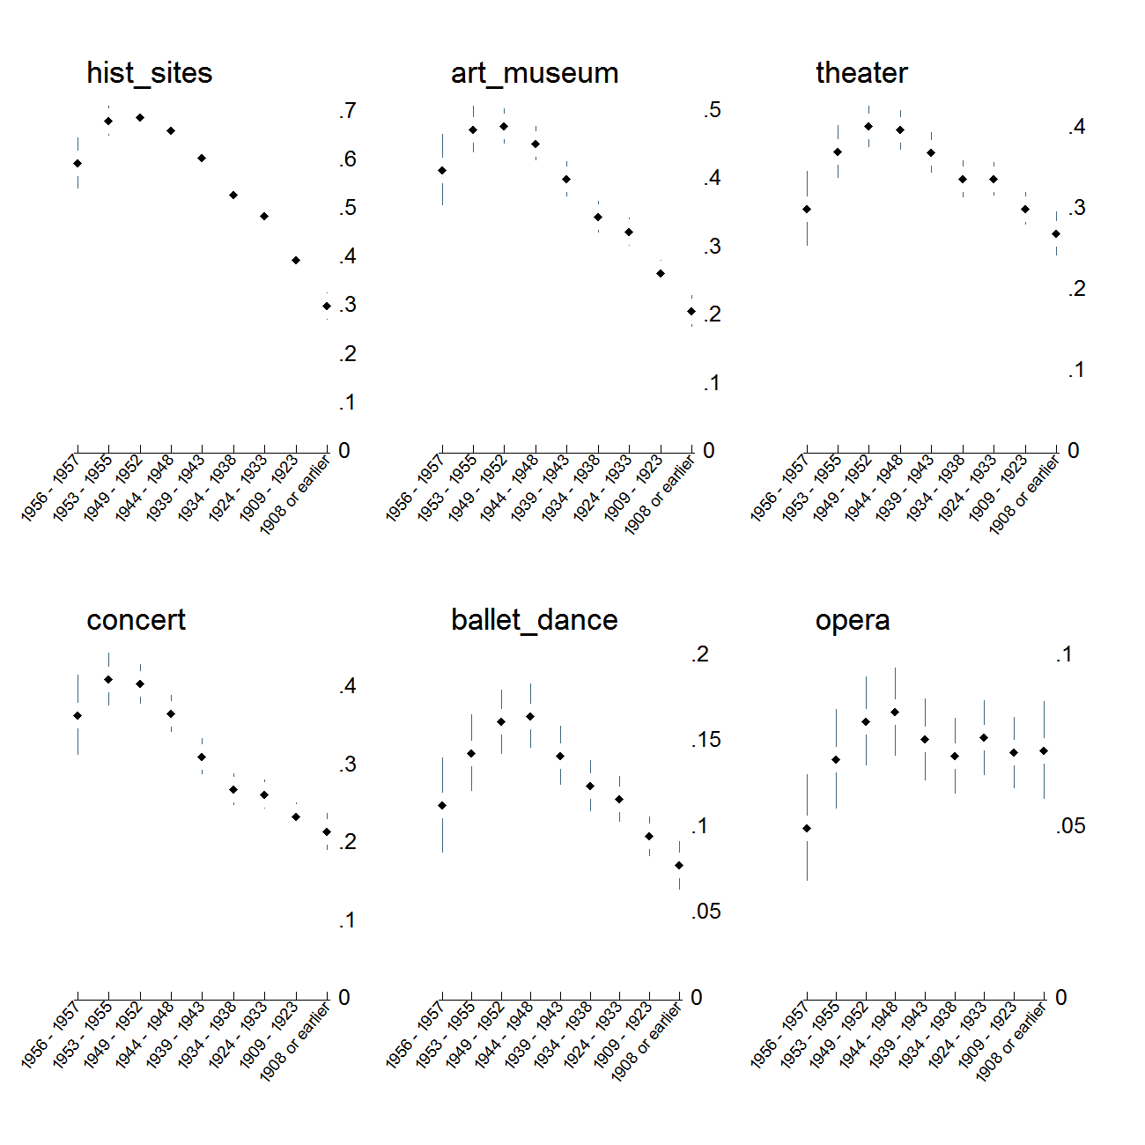
Figure 1. Predicted probability of exposure to the arts while growing up for members of different cohorts. Estimate are obtained from ordered logit models predicting having been exposed to the arts “often,” “sometimes,” “hardly ever,” or “never.” Plots show the additive probabilities of the first two responses adjusted for respondent's race, education, gender, and region of residence. Cohort effects are specified using both a linear and a quadratic term. Panels ordered (from top left to bottom right) according to overall popularity of activity.

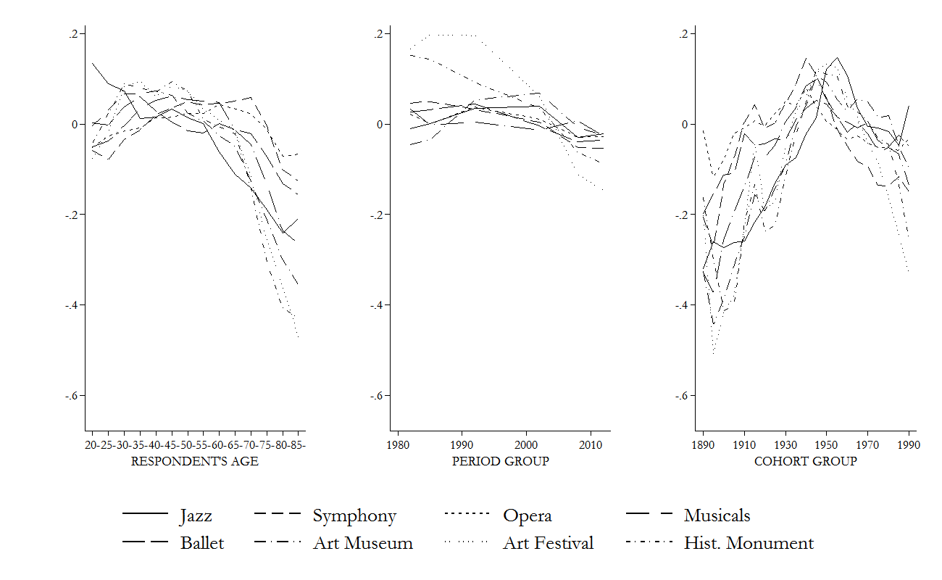Figure 2. Age, Period, And Cohort Trends For All Eight “core” SPPA Arts Participation Activities (Standardized To The Same Scale For Comparability), 1982-2012.

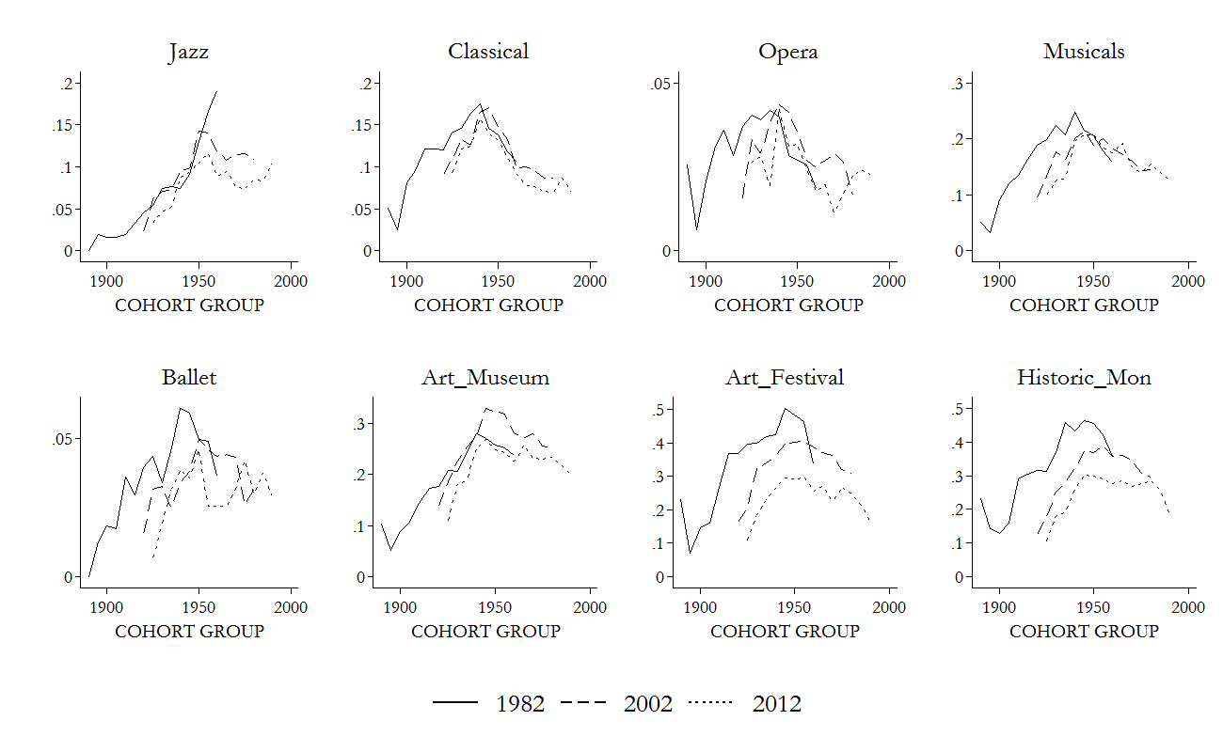Figure 3. Period-specific Cohort Trends In Arts Participation, Cumulative SPPA Data, 1982-2012.

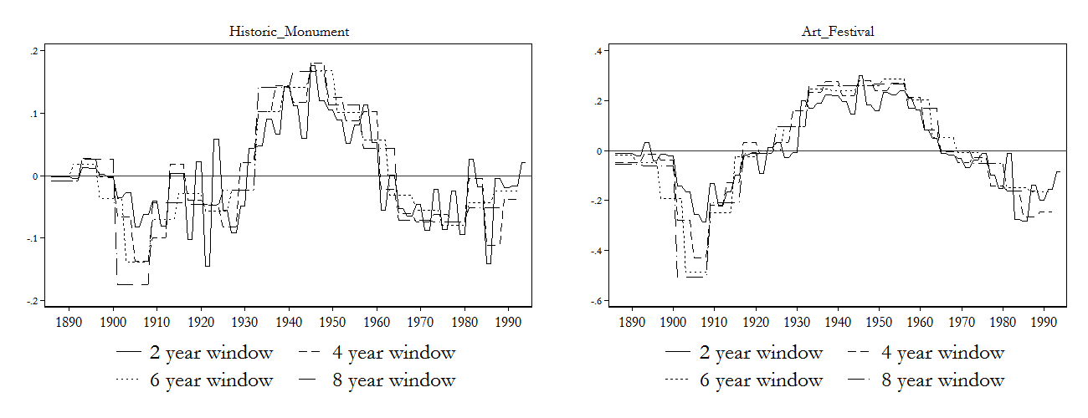
(a)
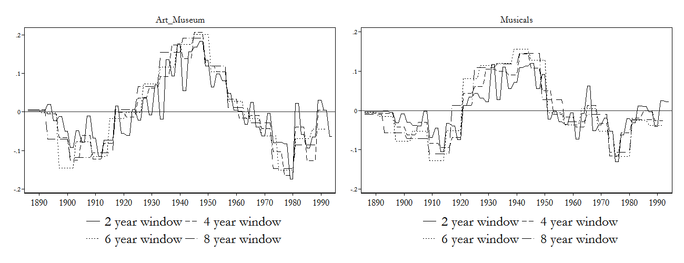
(b)
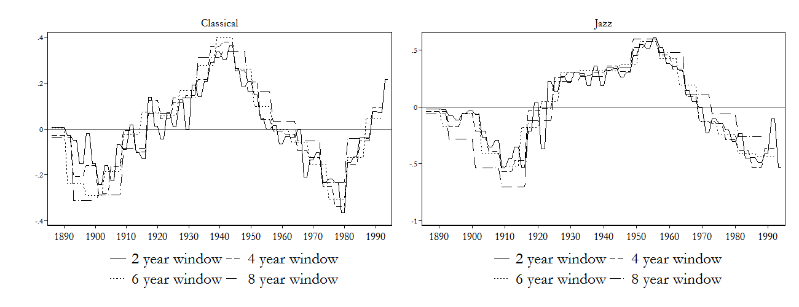
(c)

Figure 4. Random effect estimates of group level cohort effects using different window sizes to define cohort groups and fixed effects for period. Positive deviations indicate larger than expected participation for that cohort group, while negative deviations indicate smaller than expected rates. Age effect is specified as a cubic polynomial, period effects are entered as a series of dummy variables for survey year.

Over the course of the program, “total employment reached 3,749 persons. Works ranging from sculpture, murals, oils, and mosaics to craft articles, Navajo blankets, portraits, and stage sets, totaling in all 15,663 pieces, were completed. The total cost of the project was $1,312,000, of which 90.3 per cent went in wages to the artists themselves” (McDonald 1969: 62). Projects that were unfinished when PWAP was disbanded in 1934 received ongoing support from the Emergency Work Relief Program of FERA. Artworks that were federal property were dispersed to public and nonprofit institutions until July, 1935.
The output and impact of the Federal One projects may, in fact, pale in comparison to the achievements of many state and local relief administrations. New York’s was first among these, “almost unique in its progressive attitude,” and with significant reach: one accounting estimates that 12,000 people came to see a performance of Uncle Tom’s Cabin in Crotona Park (McDonald 1969: 70).
The Federal Writers’ Project paid creators of books, poetry, pamphlets, leaflets, and radio scripts including socio-ethnic studies; expositions on industrial, labor, society, and community issues; and documents of American and Native American folklore (see Griswold 2016 for an in-depth discussion). The Federal Music Project produced a similarly massive array of works including over 1,500 compositions by 540 American composers, performed by symphony orchestras, small orchestral ensembles, string quartets, chamber music ensembles, and operatic and light opera concert ensembles; grand opera, light opera, and chamber opera companies; vocal ensembles and vocal soloists; and dance orchestras, bands, and theater orchestras (Federal Works Agency 1947: 64).
Congress repeatedly attacked federal arts divisions based on reports of inefficiency and fraud. The Federal Theater project was abolished by Congress in 1939, charged with inefficiency, immorality, and infiltration by Communist agitators (N.A. 1939, “Relief: Hot Pan”). The other programs limped forward into the war years, when they were abandoned.
Data files were obtained from the National Archive of Data on Arts & Culture (NADAC) hosted by ICPSR at: http://www.icpsr.umich.edu/icpsrweb/NADAC/. Given the broad reference in the survey question to “when you were growing up,” respondents might reasonably be reporting arts exposure at any age or ages during childhood, but it would be unreasonable to interpret them as responding to arts exposure they experienced after age 18.
Exact response rates for the 1973 survey are not available; for more technical details on the American and the Arts survey series, see: http://www.icpsr.umich.edu/icpsrweb/NADAC/studies/35575?archive=NADAC&q=american+and+the+arts#method
Note that in most cases, exposure rates drop for persons born in the second half of the 1950s, which is consistent with the generational boundaries delimiting the participant generation from their successors in the results obtained from SPPA data. We would not read too much into these results as these individuals were between 16-17 years old at the time of the interview.
National Endowment for the Arts. Survey of Public Participation in the Arts 1982-2012 Combined File [United States]. ICPSR35596-v1. Ann Arbor, MI: Inter-university Consortium for Political and Social Research [distributor], 2014-12-22. http://doi.org/10.3886/ICPSR35596.v1 (Last accessed 5/25/15).
The 1982 survey holds data from 17,254 U.S. households, the 1985 survey contains information on 13,675 households, the 1992 survey pertains to 12,736 households, and the 2002 survey contains 17,135 households, the 2008 survey includes 18,444 households, and the 2012 survey has a sample size of 18,051 households, for a cumulative sample size of 97,295.
In other analyses (available upon request) we have examined variation of generational and period effects on the SPPA core participation items by gender, and race by fitting group specific HAPC models to the data.
Readers should note that our use of “participation” here is not intended to capture DIY, art-making, or other activities.
Note that in this sense, our use of the term “participation in the arts” excludes DIY art production and self-edification activities (e.g. taking art classes).
Note that negative cohort deviations among younger respondents are likely to be offset by the fact that age has a positive effect on the same outcome.

